KMS認證Windows時出現「錯誤代碼0xC004C003 , 0x803F7001 」或「"錯誤：找不到產品"」，如何處理？
- 請先確認安裝的作業系統版本是否為本校授權版，若不是請重裝。
- 進入”命令提示字元”視窗
- Win7點選「開始」→在”搜尋列”輸入CMD,在上方CMD上方按右鍵選擇(以系統管理員身份執行)
- Win8,win10「開始」按右鍵→點選”命令提示字元(系統管理員)如下:

- 在”命令提示字元”視窗輸入
slmgr.vbs -ipk 暫時金鑰
slmgr.vbs -ato
( 不同作業系統輸入的暫時金鑰不同，可在以下網址查詢
https://technet.microsoft.com/en-us/library/JJ612867.aspx
或本文在後面Appendix A

EX:
slmgr.vbs -upk
slmgr.vbs -ipk 44PXH-7Y6KF-3VJC9-XBBR8-HVTGG
slmgr.vbs -ato
如下所示:
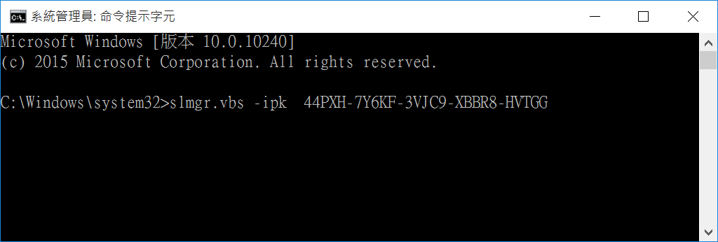

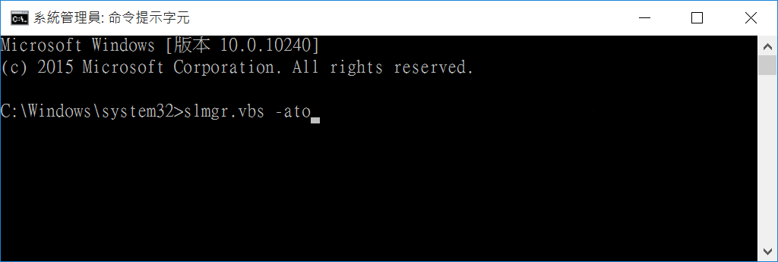
會出現
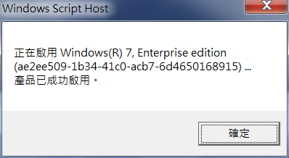
- 以上成功後,再重新以本校的認證方式重新認證一次即可

Appendix A: KMS Client Setup Keys

Windows Server 2016

Operating system edition | KMS Client Setup Key
Windows Server 2016 Datacenter | CB7KF-BWN84-R7R2Y-793K2-8XDDG
Windows Server 2016 Standard | WC2BQ-8NRM3-FDDYY-2BFGV-KHKQY
Windows Server 2016 Essentials | JCKRF-N37P4-C2D82-9YXRT-4M63B

Windows 10

Operating system edition | KMS Client Setup Key
Windows 10 Professional | W269N-WFGWX-YVC9B-4J6C9-T83GX
Windows 10 Professional N | MH37W-N47XK-V7XM9-C7227-GCQG9
Windows 10 Enterprise | NPPR9-FWDCX-D2C8J-H872K-2YT43
Windows 10 Enterprise N | DPH2V-TTNVB-4X9Q3-TJR4H-KHJW4
Windows 10 Education | NW6C2-QMPVW-D7KKK-3GKT6-VCFB2
Windows 10 Education N | 2WH4N-8QGBV-H22JP-CT43Q-MDWWJ
Windows 10 Enterprise 2015 LTSB | WNMTR-4C88C-JK8YV-HQ7T2-76DF9
Windows 10 Enterprise 2015 LTSB N | 2F77B-TNFGY-69QQF-B8YKP-D69TJ
Windows 10 Enterprise 2016 LTSB | DCPHK-NFMTC-H88MJ-PFHPY-QJ4BJ
Windows 10 Enterprise 2016 LTSB N | QFFDN-GRT3P-VKWWX-X7T3R-8B639

Windows Server 2012 R2 and Windows 8.1

Operating system edition | KMS Client Setup Key
Windows 8.1 Professional | GCRJD-8NW9H-F2CDX-CCM8D-9D6T9
Windows 8.1 Professional N | HMCNV-VVBFX-7HMBH-CTY9B-B4FXY
Windows 8.1 Enterprise | MHF9N-XY6XB-WVXMC-BTDCT-MKKG7
Windows 8.1 Enterprise N | TT4HM-HN7YT-62K67-RGRQJ-JFFXW
Windows Server 2012 R2 Server Standard | D2N9P-3P6X9-2R39C-7RTCD-MDVJX
Windows Server 2012 R2 Datacenter | W3GGN-FT8W3-Y4M27-J84CP-Q3VJ9
Windows Server 2012 R2 Essentials | KNC87-3J2TX-XB4WP-VCPJV-M4FWM

Windows Server 2012 and Windows 8

Operating system edition | KMS Client Setup Key
Windows 8 Professional | NG4HW-VH26C-733KW-K6F98-J8CK4
Windows 8 Professional N | XCVCF-2NXM9-723PB-MHCB7-2RYQQ
Windows 8 Enterprise | 32JNW-9KQ84-P47T8-D8GGY-CWCK7
Windows 8 Enterprise N | JMNMF-RHW7P-DMY6X-RF3DR-X2BQT
Windows Server 2012 | BN3D2-R7TKB-3YPBD-8DRP2-27GG4
Windows Server 2012 N | 8N2M2-HWPGY-7PGT9-HGDD8-GVGGY
Windows Server 2012 Single Language | 2WN2H-YGCQR-KFX6K-CD6TF-84YXQ
Windows Server 2012 Country Specific | 4K36P-JN4VD-GDC6V-KDT89-DYFKP
Windows Server 2012 Server Standard | XC9B7-NBPP2-83J2H-RHMBY-92BT4
Windows Server 2012 MultiPoint Standard | HM7DN-YVMH3-46JC3-XYTG7-CYQJJ
Windows Server 2012 MultiPoint Premium | XNH6W-2V9GX-RGJ4K-Y8X6F-QGJ2G
Windows Server 2012 Datacenter | 48HP8-DN98B-MYWDG-T2DCC-8W83P

Windows 7 and Windows Server 2008 R2

Operating system edition | KMS Client Setup Key
Windows 7 Professional | FJ82H-XT6CR-J8D7P-XQJJ2-GPDD4
Windows 7 Professional N | MRPKT-YTG23-K7D7T-X2JMM-QY7MG
Windows 7 Professional E | W82YF-2Q76Y-63HXB-FGJG9-GF7QX
Windows 7 Enterprise | 33PXH-7Y6KF-2VJC9-XBBR8-HVTHH
Windows 7 Enterprise N | YDRBP-3D83W-TY26F-D46B2-XCKRJ
Windows 7 Enterprise E | C29WB-22CC8-VJ326-GHFJW-H9DH4
Windows Server 2008 R2 Web | 6TPJF-RBVHG-WBW2R-86QPH-6RTM4
Windows Server 2008 R2 HPC edition | TT8MH-CG224-D3D7Q-498W2-9QCTX
Windows Server 2008 R2 Standard | YC6KT-GKW9T-YTKYR-T4X34-R7VHC
Windows Server 2008 R2 Enterprise | 489J6-VHDMP-X63PK-3K798-CPX3Y
Windows Server 2008 R2 Datacenter | 74YFP-3QFB3-KQT8W-PMXWJ-7M648
Windows Server 2008 R2 for Itanium-based Systems | GT63C-RJFQ3-4GMB6-BRFB9-CB83V

Windows Vista and Windows Server 2008

Operating system edition | KMS Client Setup Key
Windows Vista Business | YFKBB-PQJJV-G996G-VWGXY-2V3X8
Windows Vista Business N | HMBQG-8H2RH-C77VX-27R82-VMQBT
Windows Vista Enterprise | VKK3X-68KWM-X2YGT-QR4M6-4BWMV
Windows Vista Enterprise N | VTC42-BM838-43QHV-84HX6-XJXKV
Windows Web Server 2008 | WYR28-R7TFJ-3X2YQ-YCY4H-M249D
Windows Server 2008 Standard | TM24T-X9RMF-VWXK6-X8JC9-BFGM2
Windows Server 2008 Standard without Hyper-V | W7VD6-7JFBR-RX26B-YKQ3Y-6FFFJ
Windows Server 2008 Enterprise | YQGMW-MPWTJ-34KDK-48M3W-X4Q6V
Windows Server 2008 Enterprise without Hyper-V | 39BXF-X8Q23-P2WWT-38T2F-G3FPG
Windows Server 2008 HPC | RCTX3-KWVHP-BR6TB-RB6DM-6X7HP
Windows Server 2008 Datacenter | 7M67G-PC374-GR742-YH8V4-TCBY3
Windows Server 2008 Datacenter without Hyper-V | 22XQ2-VRXRG-P8D42-K34TD-G3QQC
Windows Server 2008 for Itanium-Based Systems | 4DWFP-JF3DJ-B7DTH-78FJB-PDRHK

